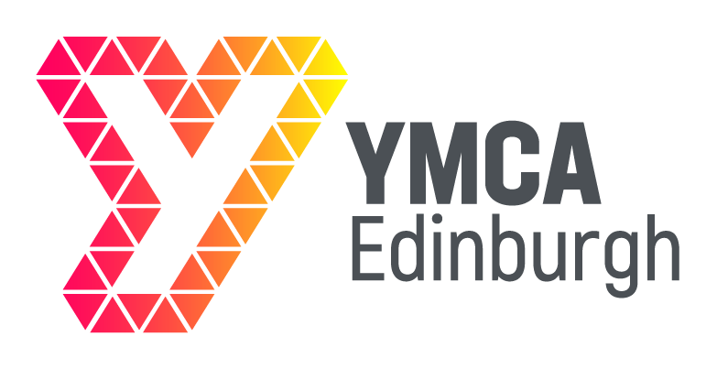
WOMEN'S GROUP
A supportive, trauma-informed women's activity group
When: Wednesdays, 11:30am - 1:30pm
Where: YMCA Edinburgh, 86 Great Junction Street, Edinburgh EH6 5LL
Pre-arranged drop-in. Please contact before attending.
Come and join our group
We offer great activities, lunch, refreshments and fun.
We’re a friendly bunch!
Contact: Maureen McGonigle
Phone: 07936 928811
Email: maureen@ymcaedinburgh.com
Website: ymcaedinburgh.com

